**System Power Up**

**Dec 2011**

Equipment power buttons are numbered 1 to 4 to match power up sequence

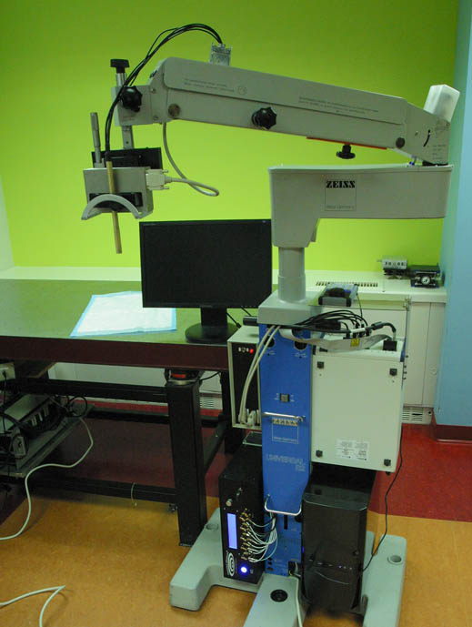

1. Turn on PXI-chassis (white crate)
2. Turn on PC and wait for OS to load
3. Turn on Daxsonics pulser/receiver
4. Turn on motor amplifier box
5. Run RealTime.vi shortcut on PC

**4**

1. Start LabView VI (button with right

**1**

arrow or Ctrl R)

**3**

**2**

Motor will self-center when VI starts. If error occurs during scan, push stop sign button and run the VI again to recover.

Shut down sequence is reverse order of above.

When not using system, PC and chassis can be left on but Daxsonics (3) and motor amp (4) should be turned off.

Anytime chassis is turned off, power up sequence must be repeated.